**Web Programming**

**(LAB Session-12)**

**Working with PHP and MySQL**

**You need to implement a website visitor counter using PHP and MySQL.**

**A) Create a database called counterDB and create a table called visitor_counter in it.**

**B) Create a single column called “counter” in the table with property like “counter INT (10) NOT NULL”.**

**C) Create a webpage called which will be homepage of your website.**

**D) As soon as any user opens the page, you should increment and update the current value of counter column (counter = counter + 1)**

**E) Display the current count value to the user on the website screen.**

**F) Take a screenshot of the MySQL DB and Table created as part of this development through php MyAdming. Take a screenshot of visitor count displayed on the homepage of your website.**

**Output:**

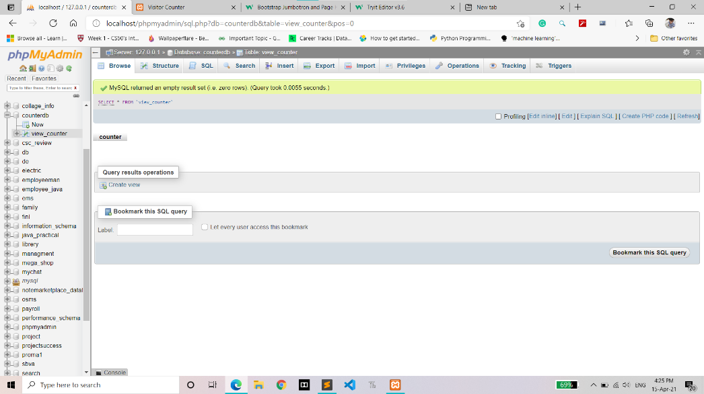

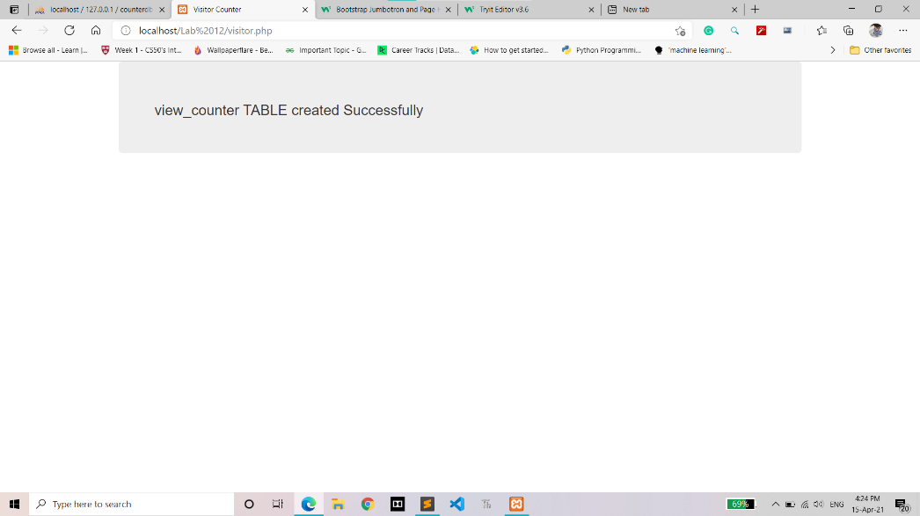

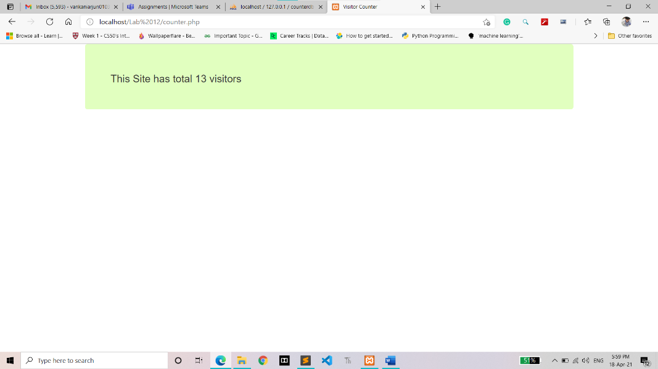

**CODE:**

**Visistor.php**

**<!DOCTYPE html>**

**<html>**

**<head>**

**<title>Visitor Counter</title>**

**<meta charset="utf-8">**

**<meta name="viewport" content="width=device-width, initial-scale=1">**

**<link rel="stylesheet" href="https://maxcdn.bootstrapcdn.com/bootstrap/3.4.1/css/bootstrap.min.css">**

**<script src="https://ajax.googleapis.com/ajax/libs/jquery/3.5.1/jquery.min.js"></script>**

**<script src="https://maxcdn.bootstrapcdn.com/bootstrap/3.4.1/js/bootstrap.min.js"></script>**

**</head>**

**<body>**

**<?php**

**$server = "localhost";**

**$user = "root";**

**$pass = "";**

**$db = "counterdb";**

**//Connection Query**

**$conn = mysqli_connect($server, $user, $pass, $db);**

**if($conn){**

**"Succfully Connected";**

**}**

**else{**

**die("Connection Failed :" .mysqli_connect_error());**

**}**

**//Create Query**

**$query = "CREATE TABLE view_counter (counter INT(10) NOT NULL)";**

**if(mysqli_query($conn, $query)){**

**echo "<div class='container'><div class='jumbotron'> <H3>view_counter TABLE created Successfully</H3></div></div>";**

**}**

**else{**

**echo "Error in creating Table :". mysqli_error($conn);**

**}**

**mysqli_close($conn);**

**?>**

**</body>**

**</html>**

**Counter.php**

**<!DOCTYPE html>**

**<html>**

**<head>**

**<title>Visitor Counter</title>**

**<meta charset="utf-8">**

**<meta name="viewport" content="width=device-width, initial-scale=1">**

**<link rel="stylesheet" href="https://maxcdn.bootstrapcdn.com/bootstrap/3.4.1/css/bootstrap.min.css">**

**<script src="https://ajax.googleapis.com/ajax/libs/jquery/3.5.1/jquery.min.js"></script>**

**<script src="https://maxcdn.bootstrapcdn.com/bootstrap/3.4.1/js/bootstrap.min.js"></script>**

**</head>**

**<body>**

**<?php**

**$server = "localhost";**

**$user = "root";**

**$pass = "";**

**$db = "counterdb";**

**//Connection Query**

**$conn = mysqli_connect($server, $user, $pass, $db);**

**if(!$conn){**

**die("Connection Failed :" .mysqli_connect_error());**

**}**

**$sql = "UPDATE view_counter SET counter = counter + 1";**

**if(mysqli_query($conn, $sql)){**

**//echo "<div class='container'><div class='jumbotron'> <H3>Counter Updated Successfully</H3></div></div>";**

**}**

**else{**

**//echo "Error updating counter :". mysqli_error($conn);**

**}**

**$sql = "SELECT counter FROM view_counter";**

**$result = mysqli_query($conn, $sql);**

**$view_count =0;**

**if(mysqli_num_rows($result) > 0){**

**while($row = mysqli_fetch_assoc($result)){**

**$view_count = $row["counter"];**

**}**

**}**

**else {**

**echo "0 results";**

**}**

**echo "<div class='container' ><div class='jumbotron'style='background-color: #E1FFBF'> <H3>This Site has total $view_count visitors";**

**?>**

**</body>**

**</html>**